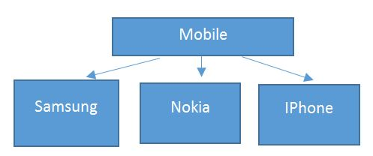

OOP Pillars:

Abstraction

1 - Dialing a number

Encapsulation

1 – Bluetooth

Polymorphism

1 – Camera

Inheritance

1 – Visibile in Diagram

Assembly 1:

Mobile, Samsung, Nokia, Iphone

Advertisement_Agency (No Inheritance)

Assembly 2:

PTA (Inheritance from Mobile)

